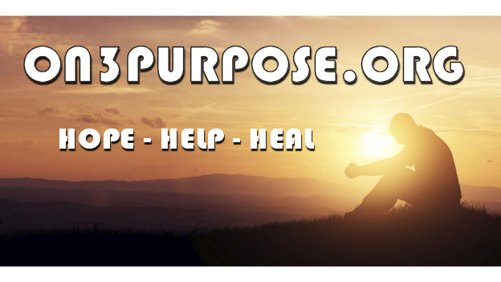
Dedicated to resources for food banks, clothing banks, recovery from substances, shelters, transitional housing, mental health services, educational assistance and more. No popups or ads, just the information needed to get the assistance you need.
You can submit resources to be added or join us on Facebook with links at the top of the page. | 